Learner: Date:
(1:2.2, 1:K6, 1:K7, 1:K8, 1:K9) (2:K25)

Task 1 Your responsibilities
Describe your responsibilities for dealing with hazards and reducing risks in the workplace.

Spotting hazards
_________________________________________________________________________________________________________________________________________________________________________________________________________
Safety inspections _________________________________________________________________________________________________________________________________________________________________________________________________________
Risk assessments _________________________________________________________________________________________________________________________________________________________________________________________________________
COSHH requirements _________________________________________________________________________________________________________________________________________________________________________________________________________

Task 2 Risks in working environments
Describe the risks associated with working environments.

Risks associated with tools
_________________________________________________________________________________________________________________________________________________________________________________________________________
What sources of information are available for tool safety?
___________________________________________________________________
Risks associated with materials _________________________________________________________________________________________________________________________________________________________________________________________________________
What sources of information are available for material safety?
___________________________________________________________________
Risks associated with spillages of oils and chemicals _________________________________________________________________________________________________________________________________________________________________________________________________________ What sources of information are available for oils and chemicals safety?
___________________________________________________________________
Risks associated with not following procedures and correct practices _________________________________________________________________________________________________________________________________________________________________________________________________________

What sources of information are available to ensure procedures are followed correctly?
___________________________________________________________________

Task 3 control measures
Give an example of when you would use each of the following control measures:
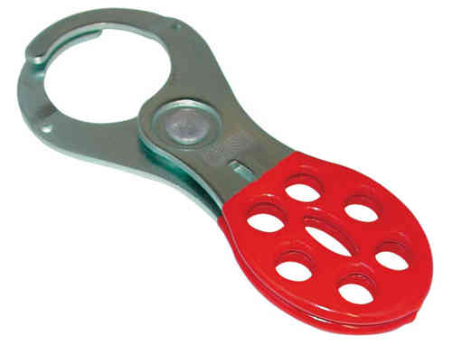 | Lock off devices
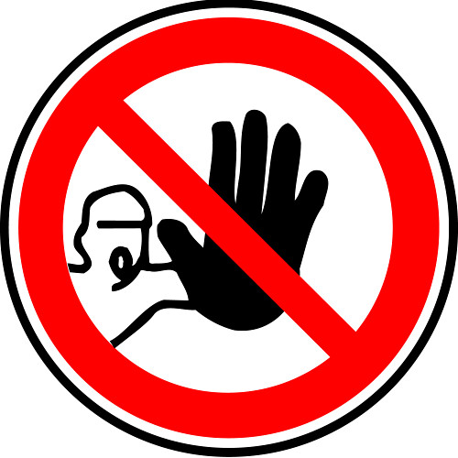 | Restricted access
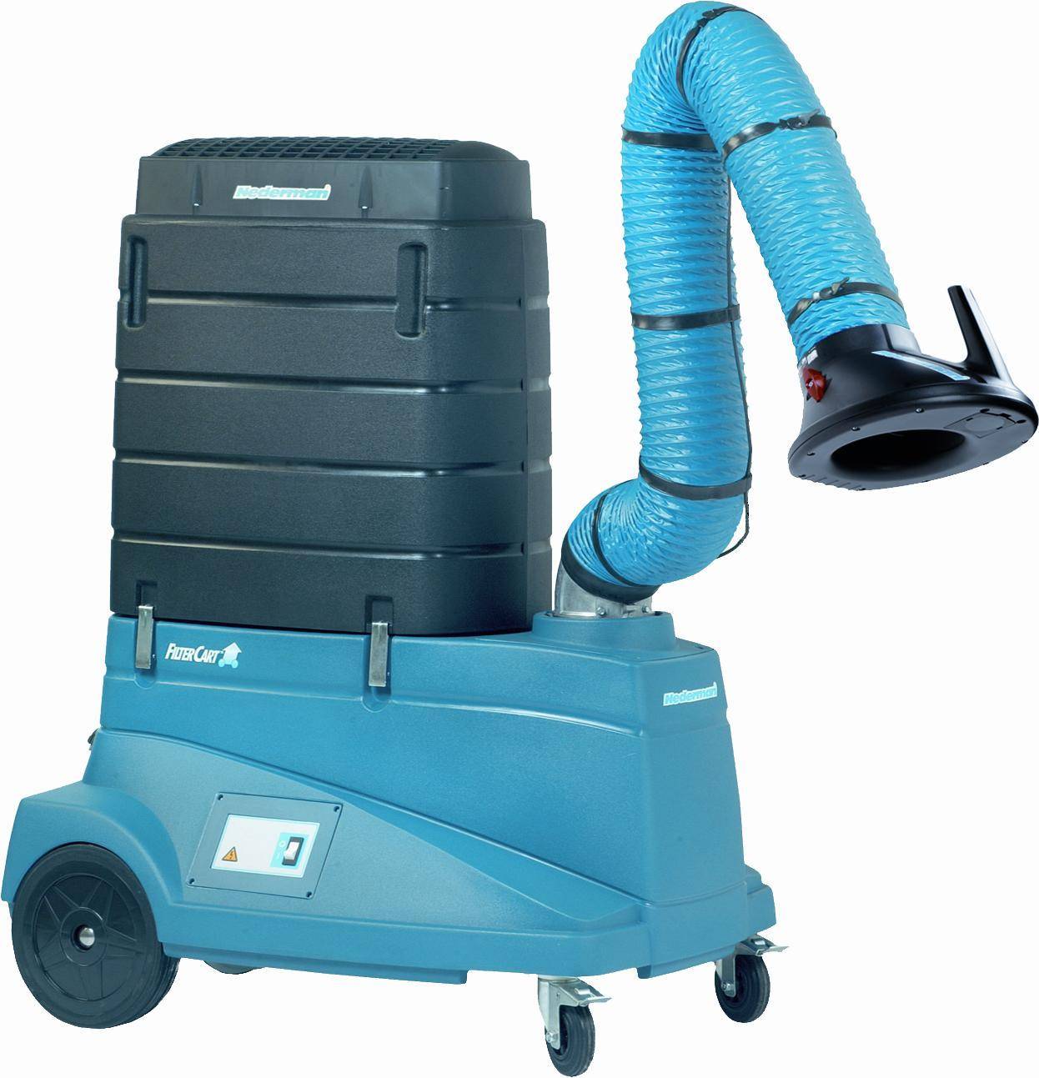 | Fume extraction
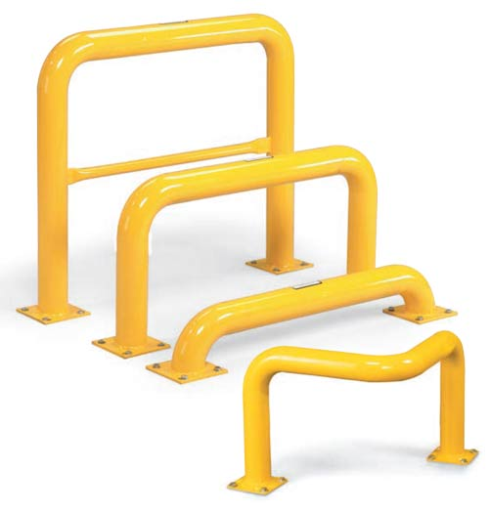 | Guards and barriers

Task 4 Safe tool storage
The images below show storage of tools and drawings.

A: tool storage B: storage of drawings
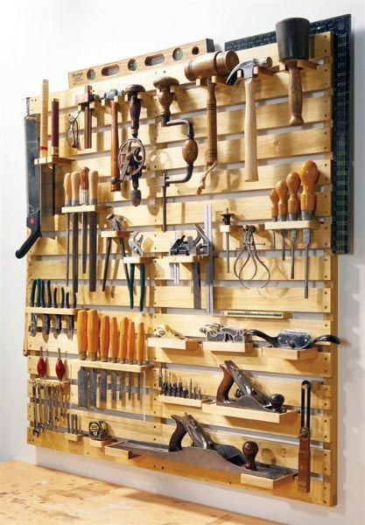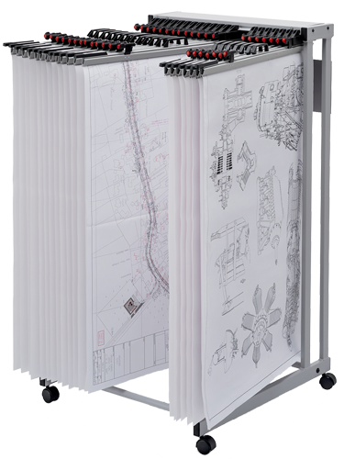

Referring to image A, explain why tools should be stored in an appropriate manner.
_________________________________________________________________________________________________________________________________________________________________________________________________________
Referring to image B, explain why drawings should be stored in an appropriate manner.
_________________________________________________________________________________________________________________________________________________________________________________________________________
Why should drawings be returned after use?
_________________________________________________________________________________________________________________________________________________________________________________________________________

